

IKT203 Algorithms and Data Structures
Project 4: Maze Navigation

Date handed out: 22 September 2021
Date submission due: 28 September 2021 23h59

Description

The problem of finding a shortest path in a maze with obstacles occurs frequently in applications such as computer games, satellite navigation and VLSI routing.

Consider a m x n grid which contains obstacles. A mouse is place in a location (x, y). The task is for the mouse to find a shortest path from its initial location to a piece of cheese if such a path exists. The mouse can only move North, East, South and West. We assume that the mouse has a map of the maze and can therefore compute the optimal, shortest path.

Programming

You will use Dijkstra’s shortest path algorithm which performs a breadth first search for finding paths in mazes. Starting at the origin of the path, the algorithm proceeds as follows:

- Starting at the source, find all new cells that reachable at distance 1, i.e. all paths that are just 1 unit in length, and mark them with that length.
- Using the distance 1 cells, find all new cells which are reachable at distance 2.
- Using all cells at distance 2 from the source, find all cells with distance 3.
- Repeat until the target is found. This expansion creates a wave front of paths that search broadly from the source cell until target cell is hit.
- From the target cell, select a shortest path (any shortest path) back to the source and mark the cells along the path.

Examples

The figures below show how the wave front propagates thru the maze and also around obstacles.

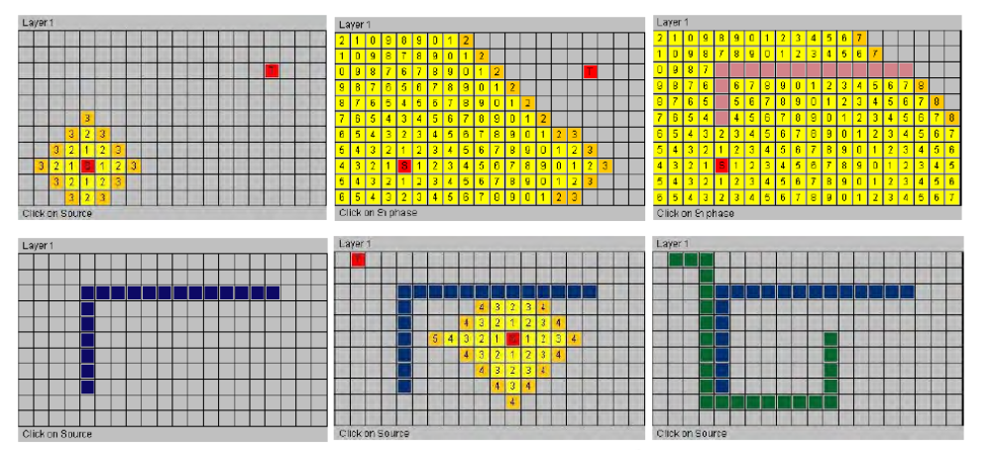

Deliverables

Write a C program that, given a source and target cell, display a graphical representation of the maze and a shortest path from source to target.

Programming Directives

- Your program must read information about the world and initial patterns from a file. Its format is as follows:

<length> <width> /* size of the maze */
<x₁ , y₁> /* (x, y)-coordinates of the first obstacle */
<x₂ , y₂> /* (x, y)-coordinates of the second obstacles */
.
.
.

- Your program must check whether a given pair <x_{i} , y_{i}> is valid.

- Your program must dynamically allocate memory space for the 2-dimensional array based on <length> <width>. The world will be displayed graphically where the geometric size of each cell is determined by the size of the world and the size of the graphics window (see more information under 3. below).

- Your graphics output must scale with the size of the world, i.e. for small mazes your program will use big blocks for each cell and smaller blocks (all the way down to single pixels) for larger mazes.

- Your program must allow to the user to interactively specify source and destination and your program must display a solution for each new (source, target) pair.

- Since there is an upper limit to the number of cells that are in the queue (what is that smallest upper limit?), you can use an array implementation of a queue. You must implement the queue as a ‘circular’ array so that you avoid having to move the remaining elements when a cell is removed from the queue.

- You must implement a queue as an abstract data type, i.e. functions InsertQueue, RemoveQueue, EmptyQueue, and FullQueue must be implemented separately from the program that finds a path through the maze. These functions must reside in a separate file and you must define a header file (e.g. queue.h) that is used by the main program.

- It will be useful to use a stack as an auxiliary data structures for keeping a record of the shortest path as your program traces its way from the destination back to the source. As a square is identified as being on the shortest path, its coordinates are pushed onto a stack; once the path is complete, the mouse simply pops the coordinates of these squares from the stack until it has reached its destination. The size of the stack is not known at compilation time; however, its size will be known as soon as the wave front has reached the destination. Thus, a fixed size stack can be dynamically allocated at runtime.

- The code for the stack, queue and application program must reside in separate files and you must use header and implementation files.

The following pseudocode clarifies the algorithms to be implemented:

/* type definitions */
typedef struct
{
int xpos;
int ypos;
} MazePosition;

typedef int **Maze;

...

void main()
{
...

/* variable declarations */
MazePosition mouse, cheese;
Queue *waveQueue;
Stack *pathStack;
Maze distance; /* distance of squares from mouse position */
Maze visited; /* must be careful with borders and obstacles;
make borders part of the maze and initialize
borders and obstacles to TRUE */

distance[mouse.xpos][mouse.ypos] = 0;
visited[mouse.xpos][mouse.ypos] = TRUE;
cheeseFound = FALSE;

insert the mouse’s position into the queue;

while ((!EmptyQueue(waveQueue) && (!cheeseFound))
{
remove the next element from the queue;

cheeseFound = the next element is the square with the cheese;

if (!cheeseFound)
{
determine the neighbor to the north;
if (the neighbor has not been previously visited)
{
mark the neighbor as visited;
update the neighbor’s distance from the mouse;
insert the neighbor into the queue;
}

determine the neighbor to the east;
if (the neighbor has not been previously visited)
{
mark the neighbor as visited;
update the neighbor’s distance from the mouse;
insert the neighbor into the queue;
}

determine the neighbor to the south;
if (the neighbor has not been previously visited)
{
mark the neighbor as visited;
update the neighbor’s distance from the mouse;
insert the neighbor into the queue;
}

determine the neighbor to the west;
if (the neighbor has not been previously visited)
{
mark the neighbor as visited;
update the neighbor’s distance from the mouse;
insert the neighbor into the queue;
}
}
}

if (EmptyQueue(waveQueue))
printf(“no path exists from (%d, %d) to (%d, %d)\n”, ...);
else
{
/* trace the path from the cheese back to the mouse using a stack */
insert the position of the cheese into the stack;

while (the mouse’s position has not been reached)
{
find a neighboring square whose distance from the mouse
is one less than the current distance;

make that square the current position;
insert the current position into the stack;
}

while (!EmptyStack(pathStack))
{
remove the next (x, y) position from the stack;
move the mouse to position (x, y);
}

the mouse eats the cheese;
}
}

Extra Credit Problem:

Assume that you are given a set of pairs of (source, target) which represent the ports of a chip. The objective is for you to connect all these pairs (s_{i} , t_{i}) with wiring. This is a typical application in circuit design (“routing”). After you have found a path connecting s_{i} with t_{i}, that path now becomes a new obstacle for subsequent paths and of course no two paths can cross; thus, subsequent paths will have to avoid the previously laid wiring. There must be a minimum distance of at least one cell between any two wires. Show a solution, if one exists, of a wiring for a set {(s_{i} , t_{i})} of all source and target points. The information about the pairs (s_{i} , t_{i}) must be read from a file.

Grading

The breakdown of the grading will be as follows:

Aspect | Marks
Initialization of the maze from a file | 10
Dynamic memory allocation for the maze | 10
Scaling of the graphics (i.e. adapt graphic block size to size of the maze) | 10
Allocation of smallest possible memory for queue and initialization | 10
Creating the wave front | 20
Finding path from target to source | 20
Following path from source to target | 10
Use of separate header and implementation files for stack and queue | 10
Total | 100
Extra Marks
VLSI routing | 20
Total | 120

